Content Approval
Document Exchange includes a fairly straightforward approval workflow mechanism. This is activated when an item has someone or a security role selected in an APPROVE permission:
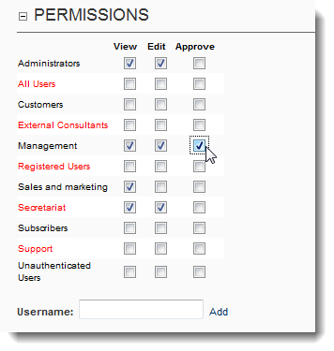
If this is done on a folder then all new items added to that folder will, by default, go through the approval workflow. This means that anyone authorized to add content can do so, but the content will not be visible until someone with approval permission has explicitly approved the item. Until that time the item is visible to the author in blue in the file list:
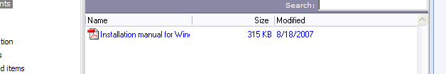
And also under the tree view item ‘My unapproved items’. For those with approval mechanism the new item will show up under the item ‘Non-approved items’:
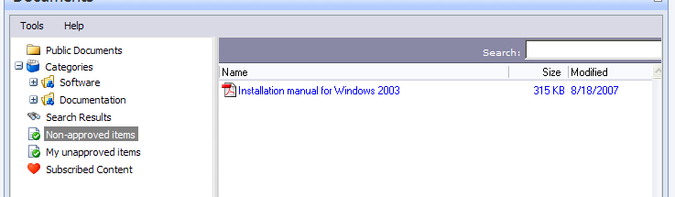
When they right-click the item they are given the option to approve.
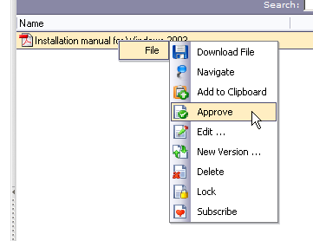
This will remove the item from the non-approved list and make it visible to those specified with view permissions.
NOTE 1: Items going through the approval workflow generate emails to the editor and approvers alike. In a nutshell: items going through approval generate more notifications than items that don’t.
NOTE 2: If you have inadvertently switched on approval on a folder and you wish to revoke this then edit the permissions of the folder and uncheck any checked approval permission checkboxes and make sure to unify permissions to the children to propagate this change to all existing underlying content.

